**Challenge 1 - Discover your own VM Knowledge and Skills**

**Member:**

Rifa Ilyasa Achrinza

Tan Jia Shun (Alan)

**Task 1 - Download BeeBox VM and Open it using the VMWare Player:**

Step 1:

Go to https://sourceforge.net/projects/bwapp/files/bee-box/ and click bee-box_v1.6.7z. After click, the bee-box_v1.6.7z file should start downloading on your device.

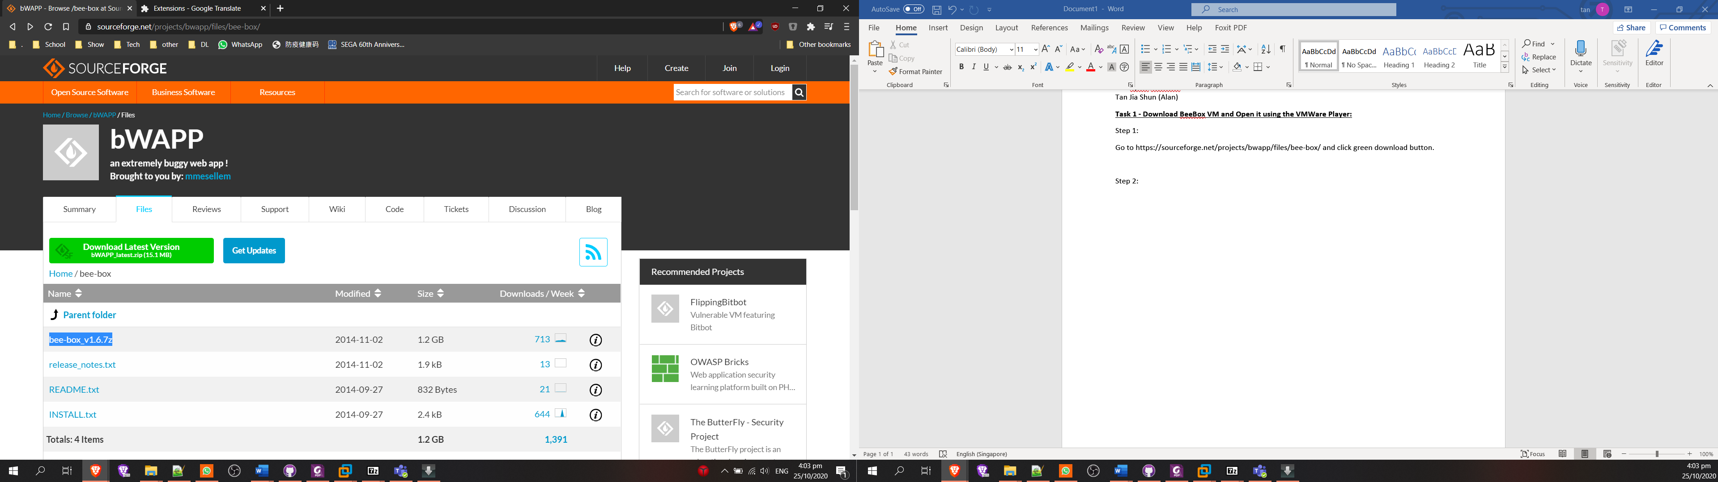

Step 2:

Unzip bee-box_v1.6.7z

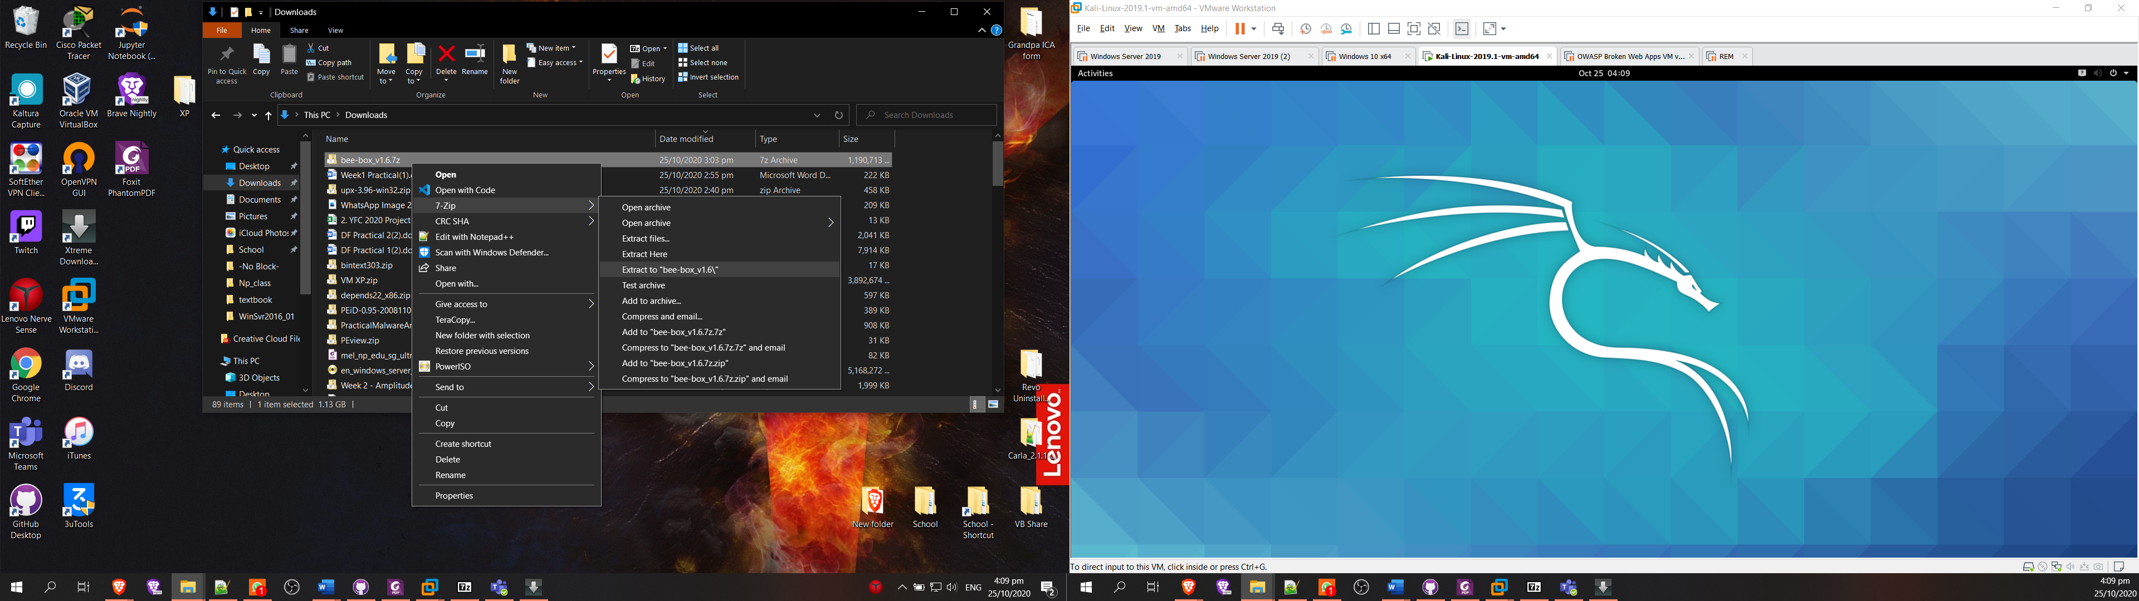

Step 3:

Go to bee-box_v1.6/bee-box, you will see bee-box.vmx, double click it. It should VMware workstation

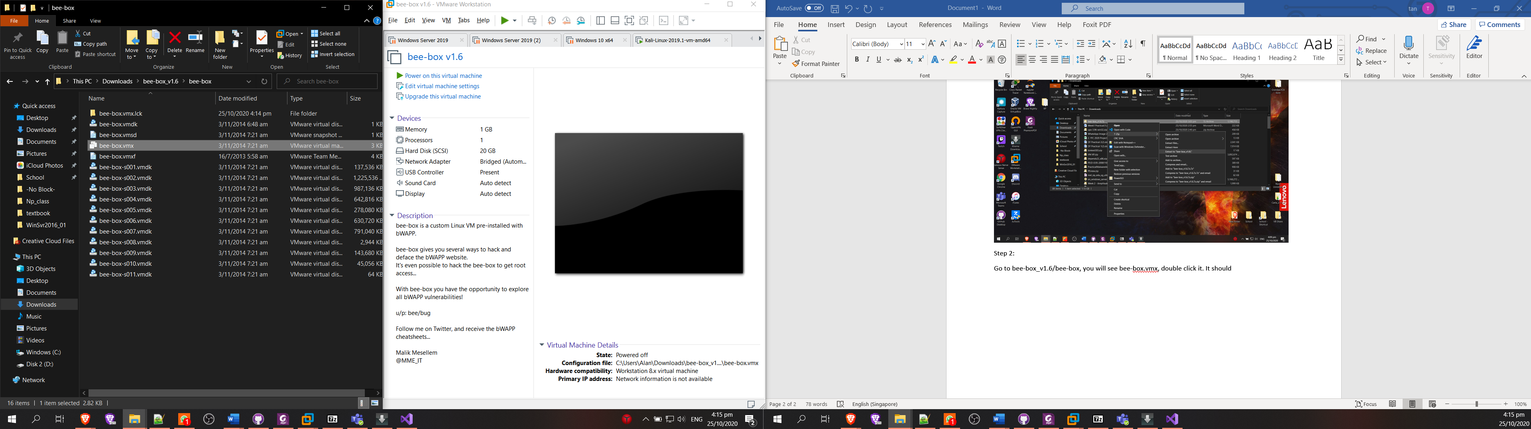

Step 4:

Power on bee-box

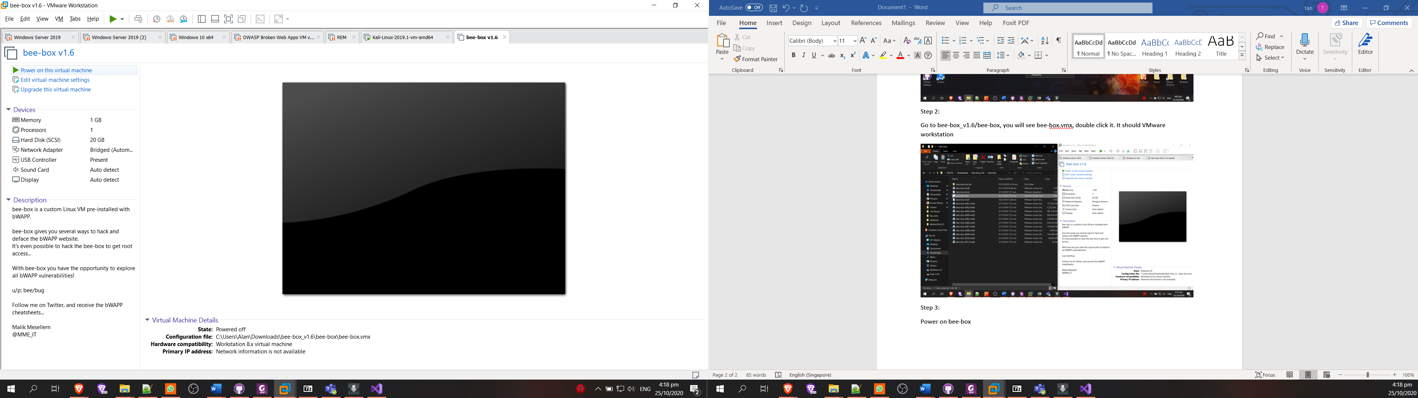

Step 5:

When bee-box start up, click bWAPP – start

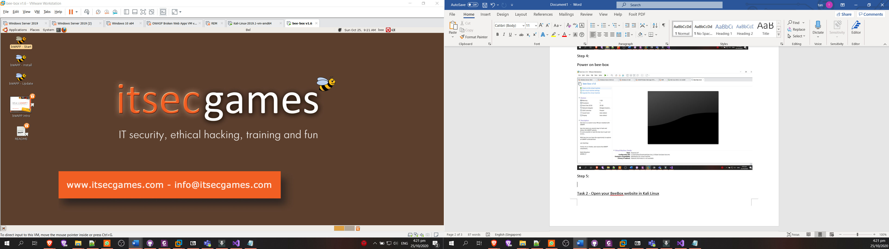

Step 6:

Login using username “bee” and password “bee”.

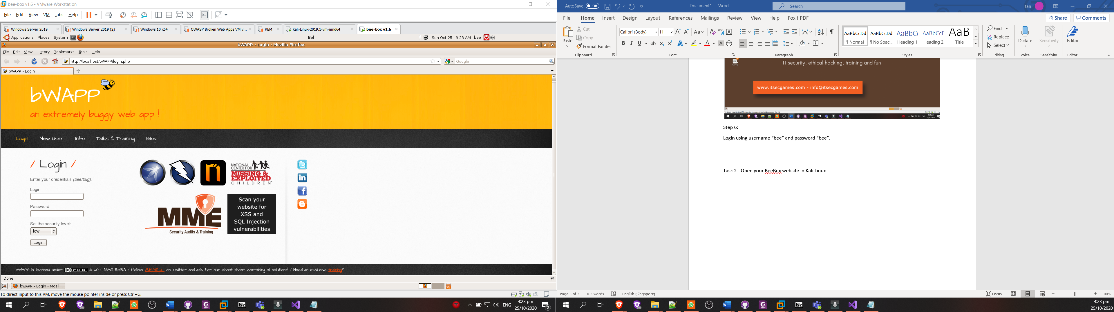

After login, you should be redirected to the page shown below.

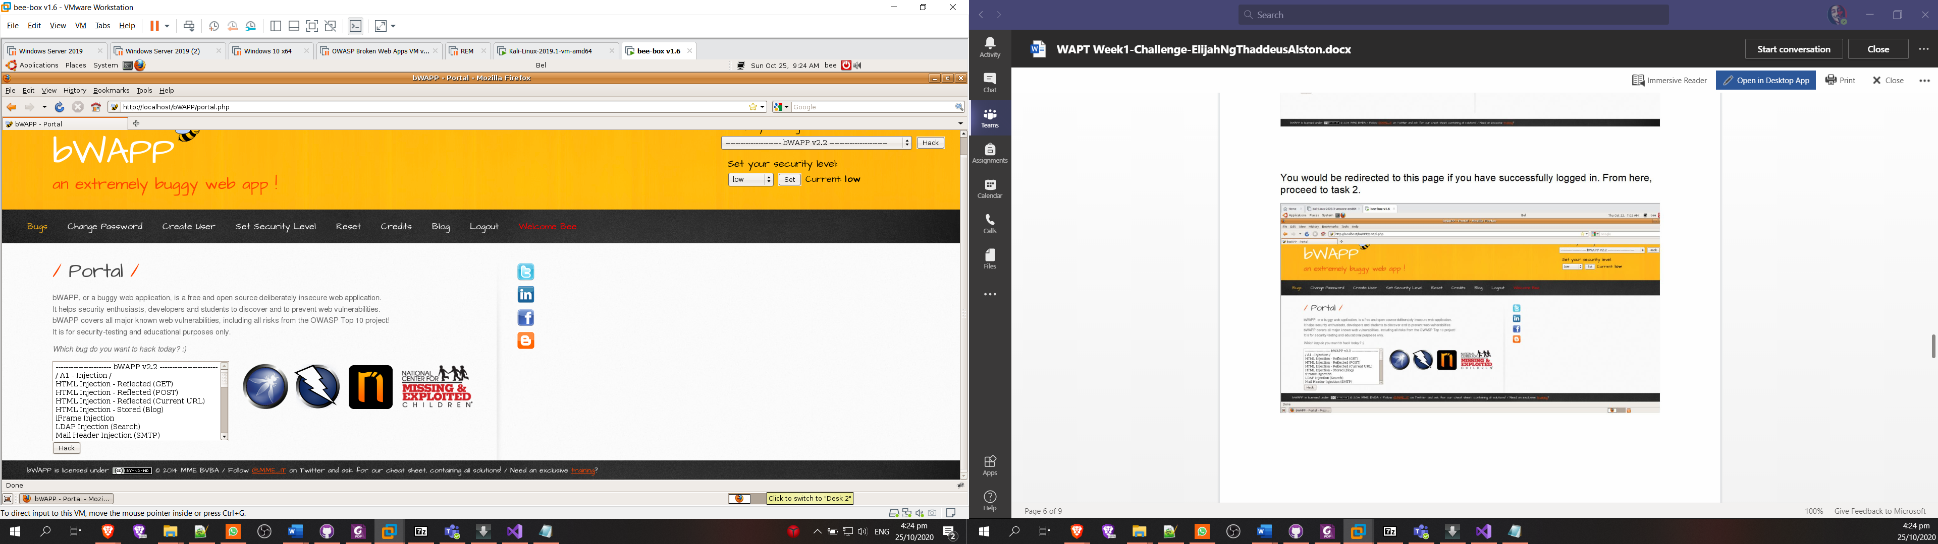

Task 2 - Open your BeeBox website in Kali Linux

Step 1: set network adapter to NAT

Click on VM on the VMware navigator, and click setting

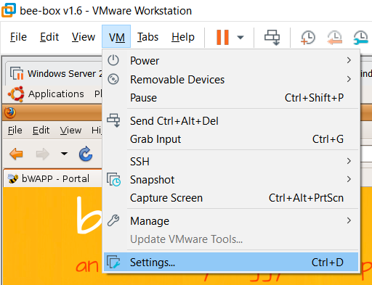

Click network adapter and select host-only for the network connection.

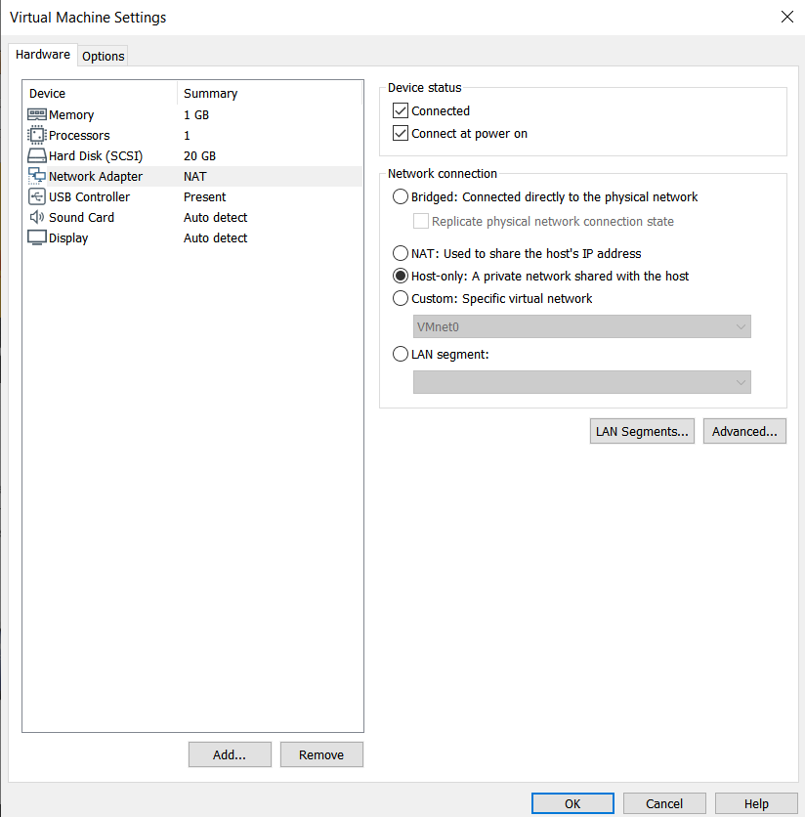

And click ok and restart the VM. Repeat step 1 for kali linux vm.

Step 2:

Open the terminal at the top left of the screen and type “ifconfig” to look to the vm ip address

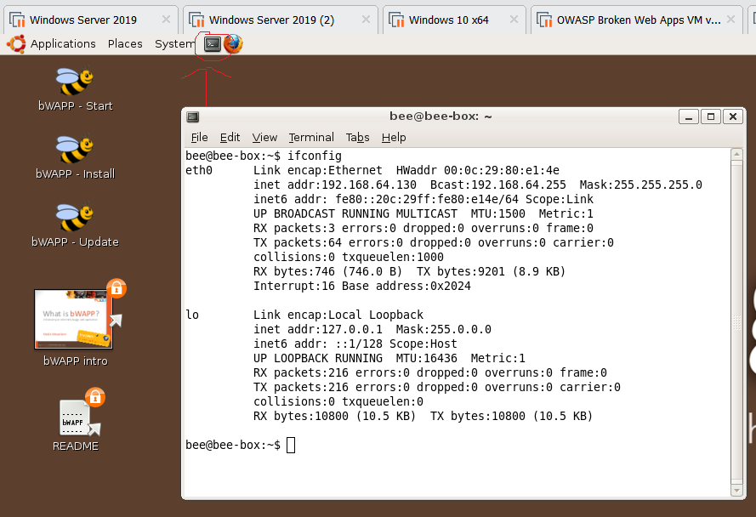

Step 3:

Go to kali linux and open the browser and type the beebox ip address and /bWAPP (ex. 192.168.64.130/bWAPP). With this, you should be at the bWAPP login page.

